**Can Tuners Give EVs a Soul — or Just More Speed?**

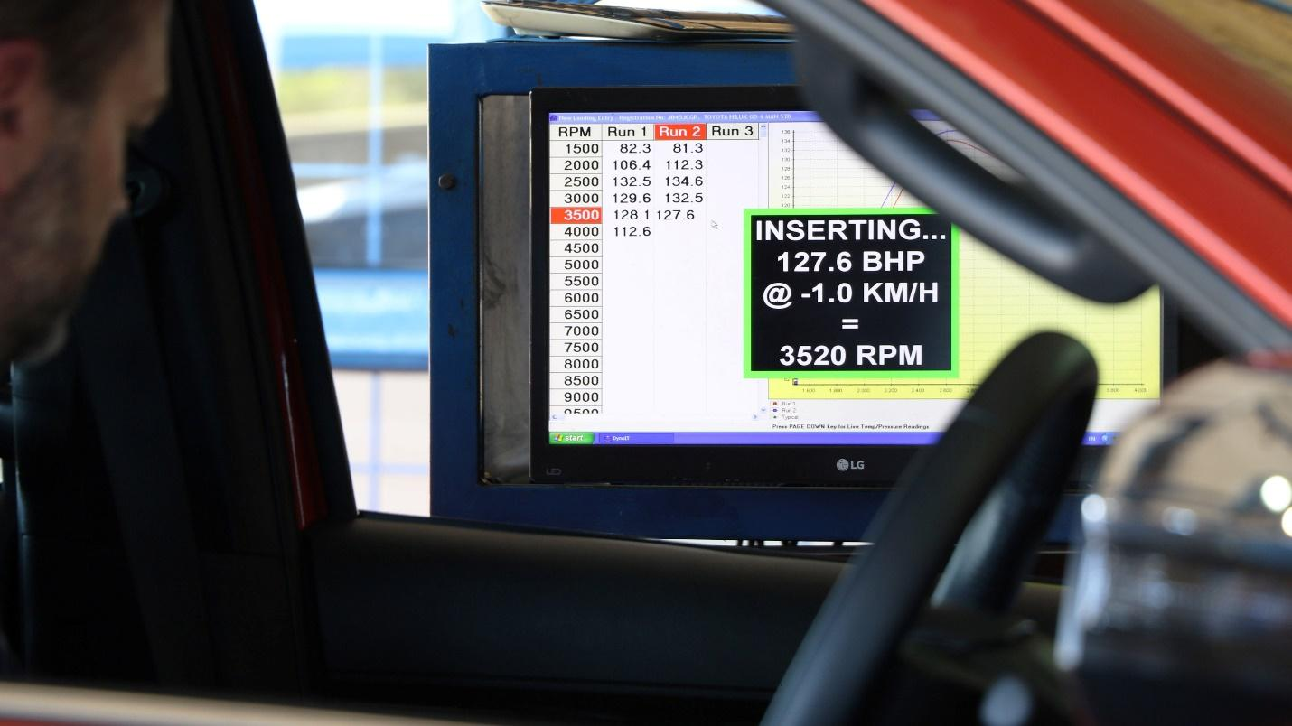

For decades, tuning culture was about more than just numbers. A high-revving engine with a custom exhaust wasn’t simply louder — it felt alive. Tuners sculpted personality into cars with ECU maps, widebody kits, intake whine, turbo spool and backfire crackle. It was sensory, mechanical and emotional.

Then came electric vehicles. Suddenly, performance became software. There’s no intake to replace, no exhaust to tune, no boost to bleed. For many enthusiasts and builders, the question isn't whether EVs can go fast — they obviously can. It's whether they can be tuned in a way that captures the soul of car culture. That question is now facing a new generation of performance shops and their answer is louder than you’d think, even if their cars aren’t.

**EV Tuning: From Curiosity to Industry Shift**

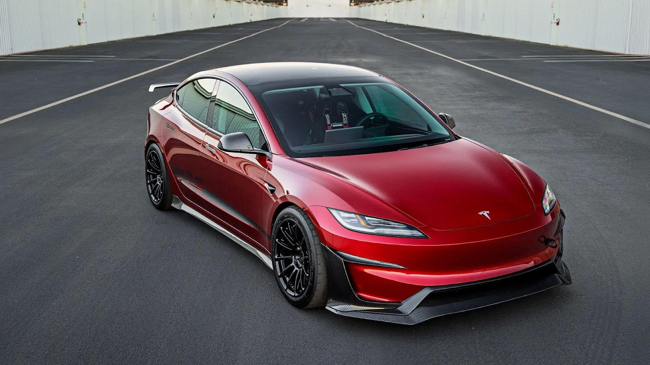

Tuning EVs once felt like a sideshow. Early mods were mostly aesthetic, wraps, wheels, maybe a lowered suspension. Any “performance tuning” was usually just a screen trick or gimmicky software overlay. Tesla owners might swap steering yokes or pay for acceleration unlocks, but the culture felt disconnected from the analog roots of tuning.

But in 2025, the game is changing. [Performance shops are starting to take EVs seriously](https://carbuzz.com/ev-owners-tuning-cars/) – not just Teslas, but vehicles from Porsche, Lucid, Hyundai and even Rivian. These builders are figuring out how to tune not just *for speed*, but *for feel*, and they’re finding real opportunities.

**What Can Actually Be Tuned on an EV?**

EV tuning may no longer revolve around intakes and exhausts, but the world of *EV performance upgrades* is thriving in its own right. Tuning shops are now focused on recalibrating drive mode software, fine-tuning throttle response, and adjusting regenerative braking to deliver a sharper, more aggressive feel behind the wheel. Suspension is another key battleground: companies like Unplugged Performance have lowered Teslas for improved track control, while others are developing custom dampers and sway bars for cars like the Hyundai Ioniq 5 N. Lightweight wheels, carbon fiber panels, and functional aero kits are also becoming popular *aftermarket electric mods*, improving both agility and battery range without compromising the futuristic aesthetic.

But beyond the visible upgrades, real performance gains are being unlocked in battery and thermal management. High-performance EVs like the Porsche Taycan and Rimac Nevera can experience power drop-offs under sustained hard driving due to heat triggering automatic cutbacks. Tuners are now writing software to delay those thresholds, improve cooling cycles, and extend peak output longer into a drive. As performance shifts from engine tuning to algorithm tuning, the future of speed is being shaped less by revs and more by refined lines of code—silent, powerful, and endlessly customizable.

**From Novitec to Unplugged Performance: Real Players, Real Progress**

The tuning world’s biggest names are slowly shifting toward electric platforms, and not just for show cars. Unplugged, for example, has built multiple track-spec Teslas, including the Tesla Model S Plaid Time Attack car that ran at Pikes Peak and Laguna Seca. These aren’t street builds with flashy LEDs; they’re fully prepped race platforms with stripped interiors, full roll cages, racing brakes and recalibrated suspension.

[**Hennessey Performance**](https://www.hennesseyperformance.com/?srsltid=AfmBOorzCR7QELT5nt9yM14Me3sMis9r16EQHLbYH2OvDYehqnNFoxyi), better known for Hellcats and hypercars, has hinted at working on EV powertrain modifications, particularly for upcoming Ram and Dodge EV platforms. Meanwhile, boutique firms in Germany and Japan are focusing on Lucid, Taycan and even Nissan Ariya performance upgrades, including battery cooling improvements and rear-motor tuning. While these projects are still relatively rare, they’re growing fast, and they’re no longer treated as outliers.